Name_________________________________

http://www.biologycorner.com/worksheets/squid_dissection.html

Squid Dissection

External Anatomy:
Find each of the parts, check the box to indicate that you found it.
1. Locate the water jet. The water jet is found on the ventral side of the squid.
2. The tentacles (long) and arms (short) are attached to the head of the squid.
3. Find the two large eyes on the side of the head.
4. Locate the body, which is covered by the mantle, and locate the two fins.
5. Each arm has sucker disks, count the number of sucker discs on one arm: ______
Sketch the external view of the squid; label all the parts that are underlined above.

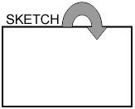
Finding the Jaw
Open up the arms and remove any that are in your way. Deep in the middle of the arms is the mouth and a beak-like jaw. These are located in a bulbous structure called the buccal bulb. Use forceps to remove the bulb and then the jaw (beak) Draw the beak in the box.

Analysis
1. How many arms does the squid have? _____ How many tentacles? ______
2. What is the function of the arms and tentacles? ______________________
3. What is the function of the water jet? ____________________________
4. Name two features that are adaptations for the squid's predatory life. _________________________
5. Name two traits that the squid shares with other mollusks. ____________________________
6. To what kingdom does a squid belong? __________________ What phylum? ________________
What class? _________________________________
7. Name one other organisms in the same CLASS ________________________________________

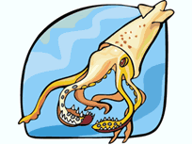
Internal Anatomy
Procedure: Turn the squid ventral side up. Pull the mantle up with the scissors where the water jet is, it should be loose and easy to pull up. Use scissors to cut from the water jet to the fins. Open the mantle to expose the structures inside and pin.
1. Find the ink sac, this is a small dark sac near the water jet. Remove the ink sac and use your dissecting needle to break the pouch. Write your initials on this paper in squid ink or just smudge the paper.
2. Find the esophagus, this is best found by looking into the mouth and seeing where it leads. The muscular mass that surrounded the beak can be pulled up (and out) to show the tube that is the esophagus.
3. To find the stomach, follow the esophagus toward the posterior.
4. The anus empties into the water jet, use scissors to cut the water jet down the center so you can see the small opening of the anus.
5. Locate the gills, these are feathery structures that may be hidden under other things, there are two of them.
6. Follow the gills toward the interior to find an enlarged structure at their base: this is the gill heart.
7. All the way toward the fin is a whitish or yellowish structure: this is the gonad. The male gonad is generally white, the female gonad is usually more yellow to clear. Is your squid male or female? ____________________
8. The hard shell-like structure that lies along the backside of the squid is the pen. See if you can remove the pen in one piece. The pen serves to stabilize the squid while it swims (like our backbone).

Observations and Analysis
- How many gills does the squid have? _______________________________
2. Where does the ink sac empty into? ___________________________________
What is its function? ___________________________________________________
3. What is the function of the pen? ________________________________________
4. Where do wastes exit the squid? (be specific) ___________________________

Word Bank
Stomach
Ink sac
Esophagus
Gill
Heart
Gonad
Anus
Pen

Use the descriptions above to help you label the squid
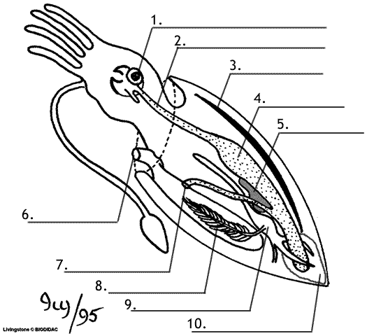

Vocabulary:
Cephalopod:

Mantle:

Funnel:

Dorsal:

Ventral:

Anterior:

Posterior:

Jet propulsion:

Pen:

Beak:

BACKGROUND INFO:

The squid is one of the most highly developed invertebrates. It is in the phylum Mollusca,
which is derived from the Latin word meaning “soft body”. It belongs to the class Cephalopoda,
meaning “head-footed”, because its head is pushed down toward the foot. This class also includes
the octopus, cuttlefish and ancient nautilus.
All mollusks have a soft body with a special covering called the mantle, which encloses all
of the body organs such as heart, stomach and gills. Squid have a large mantle, eight arms with
two longer feeding tentacles all with suckers, a beak and mouth, a siphon, a large head (with a
brain), two large eyes, and three hearts. The tentacles are long and retractable and have suckers
only at the tips. Their large eyes are very similar in structure to people's eyes. The shell has been
reduced to a chitinous pen that is embedded in the upper surface of the mantle.
Squid breathe using gills. They move by squirting water from the mantle through the
siphon, using a type of movement called jet propulsion. They can move both backward and forward
just by changing the direction of the water flow through siphon.
Some of the animal’s structures explored in this lesson illustrate the ways in which the
squid has adapted to life in the ocean. Its streamlined body and jet propulsion make the squid a
fast, active predator. This animal also has a very good defense mechanism.
Squid can change the color of their skin to mimic their environment and hide from
predators. When in danger, squid release a cloud of dark ink from their inc sac in order to
confuse their attacker and allow the squid to escape.
These fast-moving carnivores catch prey with their two feeding tentacles, then hold the
prey with the eight arms and bite it into small pieces using a parrot-like beak. The esophagus runs
through the brain, so the food must be in small pieces before swallowing. Squid feed on small
crustaceans, fish, marine worms, and even their own kind!
Squid reproduce sexually by releasing eggs into the water. After mating, a female squid
will produce 10-50 elongated egg strings, which contain hundreds of eggs in each string. In many
species, the parents will soon die after leaving the spawning ground. The egg strings are attached
to the ocean floor, are left to develop on their own, and hatch approximately ten days later.
Squid are an important part of the ocean food web. Squid are a major food source for
many fishes, birds and marine mammals. Squid are gaining popularity as a food source for humans
around the world (calamari). However, over-fishing is a growing concern because there are no
regulations on squid harvesting.
Squid can be as small as a thumbnail, or as large as a house. The giant squid,
Architeuthis, can measure 60 ft. in length and weigh three tons! Southern California squid
populations spawn mainly in the winter (December to March). Squid are seined commercially at
their spawning grounds. About 6,000 metric tons are taken yearly for human food and bait.

Squid Dissection Teacher's Guide
Original Document: Squid Dissection
Squid can be purchased from biological supply companies, such as carolina.com or you can buy them at the grocery store packaged as frozen calamari.

External Anatomy (Labeled) :

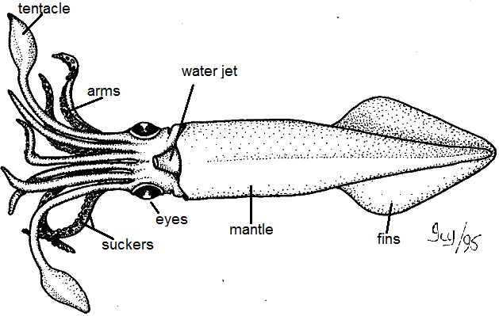

Finding the Jaw
The beak should look like a bird's beak, with two sharp curved points.
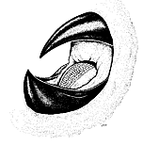

Analysis
1. How many arms does the squid have? ___8__ How many tentacles? _2____
2. What is the function of the arms and tentacles? ____grasping prey___________
3. What is the function of the water jet? __ propulsion; movement _______________
4. Name two features that are adaptations for the squid's predatory life. tentacles, water jet, large eyes, fins
5. Name two traits that the squid shares with other mollusks. ___ soft body, body cavity (coelom), bilateral symmetry __________
6. To what kingdom does a squid belong? Animalia ____What phylum? __ Mollusca ______ What class? __ Cephalopoda ___
7. Name one other organisms in the same CLASS ____ snail, slug, clams, oysters ________________

Internal Anatomy
[ Instructions omitted, see original ]

Observations and Analysis
1. How many gills does the squid have? ______ 2 _________________
2. Where does the ink sac empty into? __ water jet _______________________________
What is its function? _______ distract predators; defense ________________________________________
3. What is the function of the pen? ______ stabilize squid for swimming ______________________
4. Where do wastes exit the squid? (be specific) _____ anus then water jet _____________
Word Bank for Squid Labeling
Stomach
Ink sac
Esophagus
Gill
Heart
Gonad
Anus
Pen

Use the descriptions above to label the squid
